1.

A . Freelancer + Client + Admin Ticket issue ------ Done

1. Reply mail did not received.
2. Send mail, cant see.
3. Need inbox, outbox in admin.

B . Solved and Unsolved button issue ---------- Done

C. Add To email in problem ticket email form ------- Done

2.

A. Client + Freelancer + naluacer room Sign up -------- Done

B. Email verification method for all ------- Done

C. Add username for all 3 types ------Done

D. Password Validation ------- Done

E. skill mandatory for freelancer ------ Done

Not done, I explained. Skill dynamic

F. naluacer room panel in admin section ------- Done

G. profile activation for freelance in admin section ------ Done

Freelancer , client, naluacer sing up notification to admin

Freelancer bio fill up notification to admin

Admin active account for freelancer notified to freelancer.

User name place in after login link .

Always ID generate for all sing up case to admin.

Client sing up notification to admin

Naluancer sing up notification to admin

H. Menu disable until profile active ----------- Done

In the header all menu will stay in same place.

I . Freelancer successfully log in the sing up key will 30 by defaults ----- Done

J. Profile Title issue ---------- Done

Skill mandatory

K . Login + sing up with Gmail & Do LinkedIn. ----- Gmail Done

3.

A. User portfolio add edit and listing (design) ---- Done

Description will show while mouse hover.

B. This portfolio can be seen as public view ----- Done

In client section why old freelancers list coming in new client account.

Mail Template: ( Not for u , just a sketch for me & Shubhashis)

1. Sing up verification mail naluancer , client , freelancer

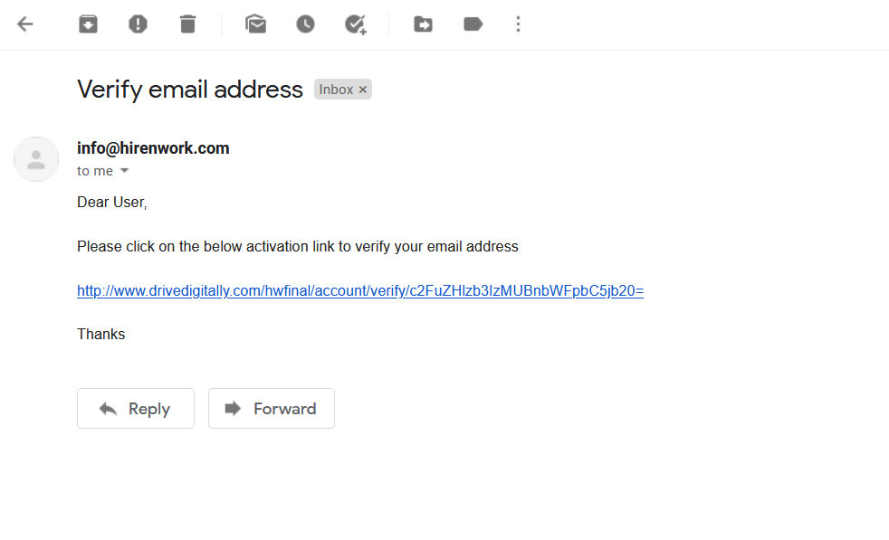

1. For freelancer profile active mail.
2. For nalauncer profile active
3. For all welcome mail